Introduction (Danielle)

* Introduction/Background/Hypothesis(what might affect increase in fires)/Blueprint (What Seasons of the year) (Danielle)
* Amazon, Australia, CA
* Sources: <https://climate.nasa.gov/news/2912/satellite-data-record-shows-climate-changes-impact-on-fires/>
  + Links inside (good data analysis)i:
    - <https://www.nature.com/articles/nclimate3329>
    - <https://www.nasa.gov/feature/goddard/2017/nasa-detects-drop-in-global-fires>
    - <https://www.nature.com/articles/ncomms8537>
* <https://www.latimes.com/projects/california-fires-damage-climate-change-analysis/>
* <https://www.aussiespecialist.com/en/sales-resources/fact-sheets-overview/weather.html> (Australian climate)
* <https://www.theguardian.com/environment/2020/oct/01/brazil-amazon-rainforest-worst-fires-in-decade> (Amazon fire)

From California to Australia to the Amazon Rainforest, forest fires have become increasingly out of control around the world. Just this September, a student in Los Angeles or the Bay Area didn’t have to see news updates to know that thousands of acres of forest were burning; a simple sniff and look at the sky would reveal the intensity of smoke in the air. Over the last several decades, the planet has experienced rising temperatures due to the increase in carbon dioxide emissions that have led to hotter and drier conditions in the atmosphere, thus increasing the likelihood of a fire starting and spreading rapidly. Warmer temperatures have led to a higher number of thunderstorms that produce lightning strikes, the main natural cause of fires (NASA's Earth Science News Team). Human land management also plays a significant role as many fires are started accidentally or intentionally for agricultural purposes. Interestingly, as fire activity has gotten worse in northern latitude forests, research has indicated that grassland and savanna ecosystems are experiencing a decline in fires. This is due to human presence enabling land regulation, resulting in a decrease in area burned globally despite a changing climate that favors wildfires. Furthermore, during the past 40 years, fire season length has increased across 25% of global vegetated land, worsening the risk of burning beyond just the summer months (December to February in Australia) and instead all year-round like in California. Both anthropogenic and environmental factors are shaping the fires we see today, and our ability to study fires using satellite data that reveals large-scale trends has improved. Our group sought to better understand the damage brought by the burning of massive amounts of land as people have been displaced, are experiencing financial losses, and may suffer from the health hazards of smoke in the future.

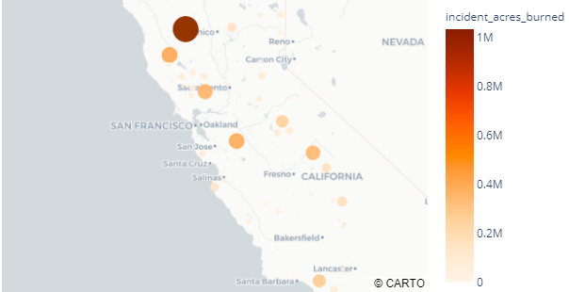

The map shows the amount of acres (in millions) burned by the wildfires across various cities in California. Moving across the state in the northern direction, there is a gradual darkening of the amber-shaded circles located near San Jose and Sacramento, with the darkest (brown) circle in Chico, indicating that the city experienced about 1 million acres of forest burned. This devastating loss of forest led to the displacement of many Chico residents, sparking a rise in home prices by about 21% and homelessness by 16% (Reuters, 2020). The data is consistent with the fact that the northern part of the west coast saw most of the devastation from the fires, as many of us can recall the frightening photos capturing the hazy, orange sky that covered the Bay Area for days. Another unfortunate outcome is the destruction of about 360,000 acres of lush grapevines and wineries in Napa Valley, the country’s most valuable region of wine production and a source of California’s billion dollar industry (National Geographic, 2020). As climate change is already negatively impacting the taste of Napa’s wines, it is evident that the warming atmosphere is fueling wildfires that not only wither away our forests, but also the spirit in our hearts.

Sources: Fire Locations (<https://www.capradio.org/articles/2020/08/20/see-where-wildfires-are-burning-in-california/>)

SF Smoky Sky photos: <https://www.sfgate.com/news/editorspicks/article/Bay-Area-sky-orange-wildfire-smoke-San-Francisco-15553461.php#photo-19934711>

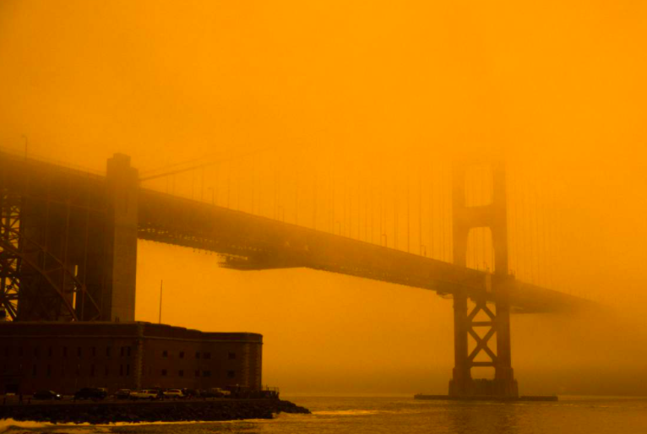

Wind/drought:

* [**https://www.theguardian.com/us-news/2020/oct/23/california-high-wildfire-risk**](https://www.theguardian.com/us-news/2020/oct/23/california-high-wildfire-risk)
* [**https://sanfrancisco.cbslocal.com/2020/09/27/butte-county-sheriff-issues-fire-evacuation-orders-for-north-complex-west-zone/**](https://sanfrancisco.cbslocal.com/2020/09/27/butte-county-sheriff-issues-fire-evacuation-orders-for-north-complex-west-zone/)

Chico displacement:

<https://www.reuters.com/article/us-usa-wildfires-displacement/refugees-in-their-own-country-as-wildfire-destroys-california-towns-idUSKBN26N1MW>

Napa Valley:

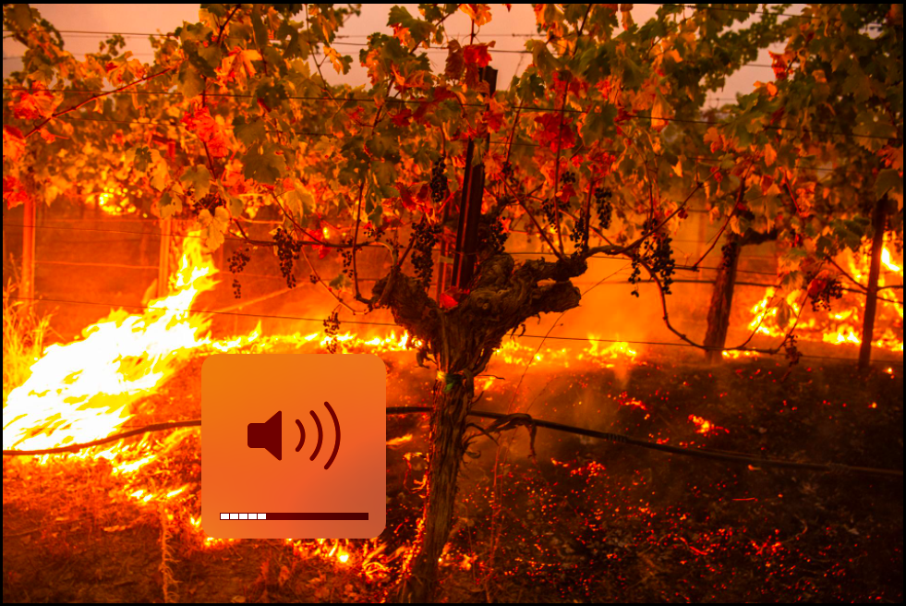

<https://www.nationalgeographic.com/travel/2020/10/wildfires-ravage-napa-valley-will-the-wine-region-survive/>